2022 Annual Report
Tucker County, WV Convention and Visitor’s Bureau
Prepared By:
Jessica Waldo
Executive Director

Mission Statement:

“The Tucker County Convention & Visitor’s Bureau, a private, non-profit sales and marketing corporation will, through aggressive sales, marketing and informational campaigns, strive to establish the Canaan Valley/Blackwater Falls/Tucker County area as a premier vacation, meeting, and special event destination thereby enhancing the tourism economy in Tucker County”

The Tucker County Convention & Visitors Bureau’s (CVB) mission is to support, sustain and assist in the growth of the Tourism Industry in the county. To fulfill that mission, the CVB expends the majority of its budget on advertising. At the end of 2022, the CVB expenditures reflected 73% on advertising, 22% on payroll, and 5% on operational. Exceeding to the WVACVB accreditation guidelines and the CVB Oversight Bill our budget should reflect 40% on advertising, 40% on payroll, and 20% on operational.

2022 Board of Directors:

- Donna Patrick, President, Canaan Valley Representative.
(Term expires 12/31/22)
- Matt Baker, Vice President, Canaan Valley Representative.
(Term expires 12/31/24)
- Tom Price, Director, Canaan Valley Representative.
(Term expires 12/31/23)
- Patrick McCann, Treasurer, Parsons Area Representative.
(Term expires 12/31/22)
- Brent Markwood, Davis/Thomas Representative.
(Term expires 12/31/23)
- Kevin White, member at large, Tucker County OEMS Director.
(Term expires 12/21/23)
- Joy Malinowski, a member at large, owner of Cooper House and the Billy.
(Term expires 12/21/24)
- Mike Rosenau, Tucker County Commission

The Staff:

- Jessica Waldo,
Executive Director
- Brian Sarfino,
Marketing Manager
- Barbara Worden, Office Administrator / Information Specialist
Director’s Notes:
The 2022 year brought consistent travel patterns. Our winter season continued to show growth, even with below average snow totals. The invested into Timberline Mountain has proven to provide a dependable winter experience. With their investment in snowmaking, they were even able to open Thanksgiving week of 2022. Spring, Summer and Fall travel showed similar numbers to 2012. Utilizing a new software, KeyData we were able to track our vacation rental occupancy. This new program provided that our occupancy was up 18% in 2022 compared to 2021. Seeing the largest increase in July, closely followed by February.
Our office launched another Take in Tucker campaign, including a campaign specific for the Scavenger Hunt challenge. The Scavenger Hunt specific advertising increased our participants in the challenge to over 250. This campaign brought in over 22 million impressions and an impressive 59,369 clicks.
Our Take in Tucker campaign, launched a new video series that ran all four seasons. These videos were intended to give the perspective of frequent travels to the area and let them tell why they love Tucker County. They are stored on our youtube channel and will be reutilized and expanded on for 2023. The spring/summer campaign had over 29 impressions and 24,025 clicks. The fall campaign had over 6 million impressions and 11,892 clicks.
Prior to the 4th of July holiday, we had lodging partners expressing slow bookings. We worked with our agency to put together a Tucker Lodging specific campaign. That ran from the end of June through the month of July. This specific campaign brough in over 2 million impressions to our lodging page and 3,649 clicks.
The CVB continues to participate in the WV Tourism Co-op program. This program is designed to increase your advertising reach without increasing your budget. The WV Tourism pays for half of the advertising cost and their agency designs the artwork. The CVB provides talking points, pictures, logos and anything additional needed for the placement. The CVB finds this program to help leverage our marketing message beyond our typical placements.
In 2022, we received 11 Marketing Sponsorships requests and we awarded close to $14,000. Our requests continue to increase and we encourage organizations to apply.
The Tucker County CVB applied and passed the WV Association of Convention and Visitors Bureaus 2022 accreditation process. This is now required by state law and something our CVB has been part of since its conception. The accreditation process is intended to have oversight on CVBs throughout the state. It is required to be renewed every 3 years.

Thank you,

Jessica Waldo
Executive Director
jessica@canaanvalley.org

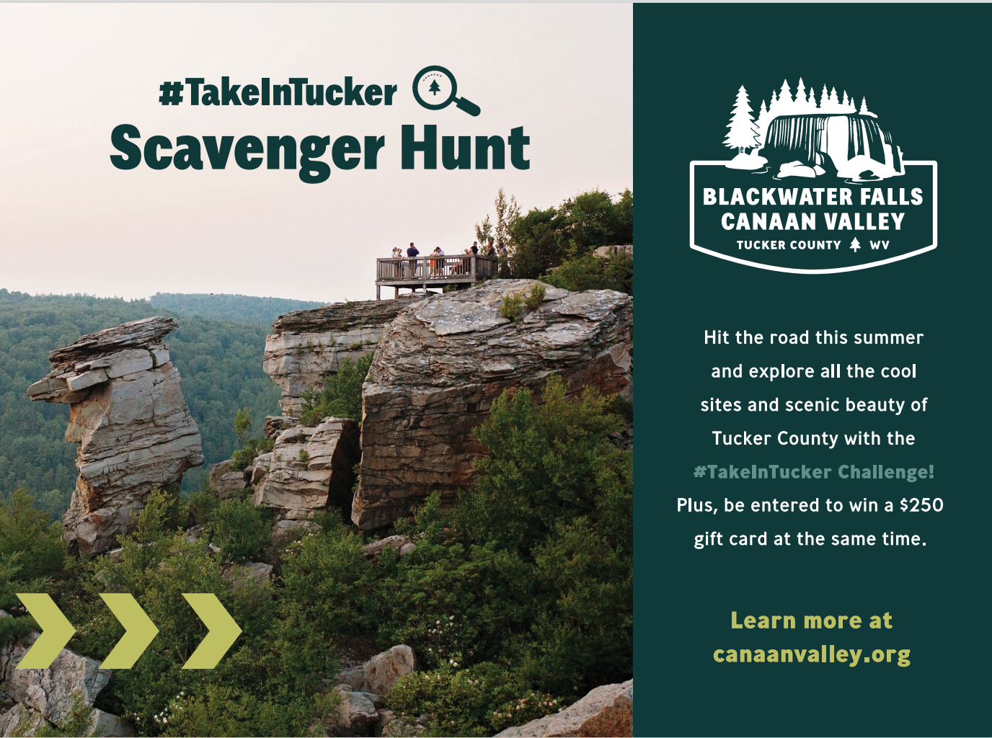
2022 Marketing “Take in Tucker”
Summer: $150,000
Fall: $20,000
Seasonal Goals:
- Promote arts and culture attractions
- Be mindful of outdoor activities and restaurants facing challenges of over tourism
- Build assets featuring storytelling of the area
- Distribute 5,000 copies of the Pocket Guide
- Build out Take In Tucker campaign
Ski The Valley 2020/2021: $130,000
Seasonal Goals:
- Promote 3 ski areas within few miles
- True Winter Destinations with Winter Experiences
- Winter Cabins/Vacation Rentals
- Captured and produced Winter Videos
- Target the Charlotte, NC area
WV Tourism Co-op: $43,836
In 2022 we continued to participate in the WV Tourism Co-Op program. This program is a 50/50 split with the WV Tourism Office. The CVB purchased over $46,000 in advertisement; 2021/2022 winter program $12,900, Summer $32,436 summer program and $1,500 Fall program.
In addition to our traditional placement, the CVB leveraged and strategized with this co-op program to target the Charlotte, NC area. During the Winter program we hired a social media influencer, that spent a few days with her family experience winter in the Tucker County. For the Spring/Summer program we utilized multiple platforms including streaming audio (pandora, spotify, etc.) and out of the home advertising (varying billboards).

Summary:
Tucker County 2022 Analytics shows that there has been a 29% increase in overall users to the canaanvalley.org website, with a total increase of 26% Sessions. Despite a decrease in Total page views due to fewer users searching for Canaan Valley organically, paid traffic saw an increase of page views by over 383.53%. Google and Facebook were the two main sources of traffic for users in 2022. Seeing a 235% increase in Paid Search traffic year over year. Paid Search traffic has been sending the most qualified traffic seeing a much lower bounce rate of only 55%.
Overall, the website is doing well. Year-to-date, sessions are up 27.52%, new users are up 30.44%, and users are up 28.82%. And while the bounce rate is up 23.79%, this is within the norms of what we expect to see during periods of heavy paid media traffic.
Recommendations:
- Continue with Google Paid Search.
- Continue successful past campaigns: Take in Tucker and Scavenger Hunt 2022, Ski the Valley 2022
- Target ages 25-55 for best engagement rate and highest goal completion rates.
- Target States: KY, OH, VA, MD, PA, OH, NC, IN, NY to increase awareness in surrounding states during future campaigns.

2022 Paid Campaign Performance:
The majority of traffic driven to the website was by the “Take in Tucker Scavenger Hunt” with over 17 million impressions and 48,200 clicks. The Facebook Ski the Valley Video provided 29,265 clicks with only 628,972 impressions. Providing at 4.65% click thru rate.
We had a total of over 75 million impressions and 190,495 clicks. With a .25% click thru rate, total cost per click was $1.06 and total cost per impression was $2.67.

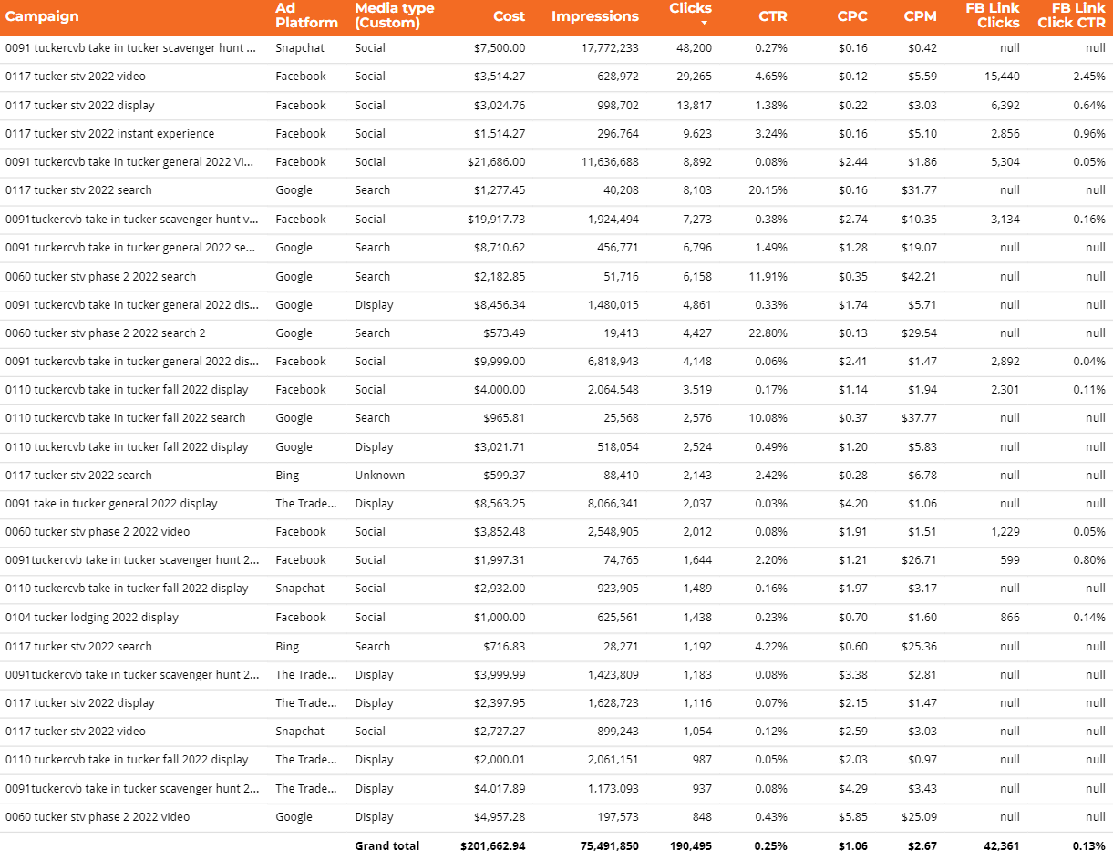

Website Stats 2022:
• Total page views: 487,533 -13.67% decrease
• Organic page views: 135,313 -52.84% decrease
• Sessions: 329,244 26.67% increase
• Users: 277,472 29.43% increase
• Average Session Duration: 0:51 -43.81% decrease
• Bounce Rate: 74.43% 16.26% up
Website Event Tracking:
Event Tracking; tracks interactions with content on the site.
• Total Events: 242,128 150.41% increase
• Organic Events: 97,285 131.70% increase
• Partner Clicks: 42,506 -35.01% decrease
• Organic Clicks: 11,863 -68.14% decrease
• Guide Request: 837 tracking started after new site launch
• Newsletter Signup: 327 tracking started after new site launch
Insight from 2022 Website Visitors:
- 71.2% of website visitors were using their mobile device, 24.8% desktop and 4% tablet
- Largest age range of website visitors:
  - 25-34 (17.6%)
  - 35-44 (22.5%)
  - 45-54 (19.8%)
  - 55-64 (17.4%)
- Top States visiting our website: 1. Virginia 2. West Virginia 3. Pennsylvania 4. New York 5. Ohio 6. North Carolina 7. Maryland 8. District of Columbia 9. Illinois 10. Florida
- Top 15 affinity categories shared by the most visitors to the site:
1. Food & Dining/Cooking Enthusiasts/30 Minute Chefs 2. Lifestyles & Hobbies/Pet Lovers 3. Lifestyles & Hobbies/Outdoor Enthusiasts 4. Banking & Finance/Avid Investors 5. Shoppers/Value Shoppers 6. News & Politics/Avid News Readers 7. Sports & Fitness/Sports Fans 8. Home & Garden/Do-It-Yourselfer 9. Travel/Travel Buffs 10. Food & Dining/Fast Food Cravers
Top States:

Top Performing Website Traffic Sources:
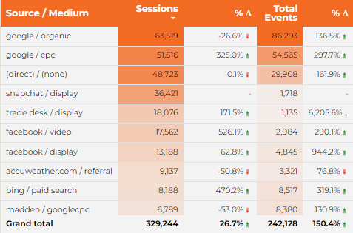

Top Traffic Landing Page Performance (Sessions):

Visitor Affinity: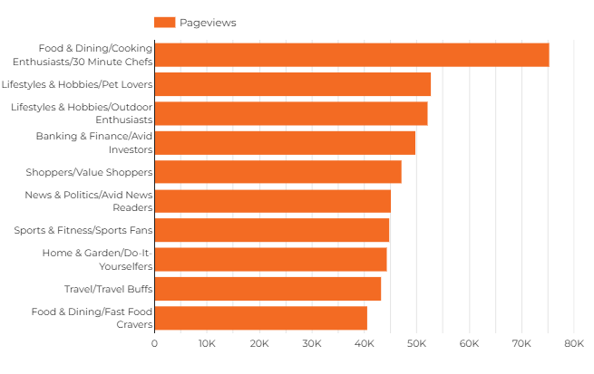

Email Campaigns: 14 total
• December 2022 It's Time To Ski The Valley
Successful deliveries: 9,903 Total opens: 3,065 Total link clicks: 166
• November 2022 You Should Visit Tucker County This Month!
Successful deliveries: 9,877 Total opens 3,181 Total link clicks: 199
• October 2022 Leaf-Peeping Season Is Here!
Successful deliveries: 9,944 Total opens: 2,872 Total link clicks: 341
• September 2022 Take In The Views This Fall In Tucker County
Successful deliveries: 9,988 Total opens: 3,249 Total link clicks: 374
• August 2022 Check Out These August Events In Tucker County!
Successful deliveries: 10,044 Total opens: 2,448 Total link clicks: 279
• July 2022 Don't Miss Free Live Music This Month!
Successful deliveries: 10,056 Total opens: 2,209 Total link clicks: 150
• June 2022 Hit the Road This Summer In Tucker County
Successful deliveries: 10,134 Total opens: 2,898 Total link clicks: 273
• May 2022 What's New In '22? Tucker Spring Round-Up!
Successful deliveries: 10,162 Total opens: 2,653 Total link clicks: 553
• April 2022 Spring Into a New Season in Tucker County
Successful deliveries: 10,229 Total opens: 2,725 Total link clicks: 694
• March 2022 Your Ultimate End-Of-Season Escape
Successful deliveries: 10,246 Total opens: 2,643 Total link clicks: 418
• February 2022 Ready To Ski The Valley?
Successful deliveries: 10,276 Total opens: 2,607 Total link clicks: 283
• January 2022 New Year Adventures in Tucker County
Successful deliveries: 10,274 Total opens: 3,028 Total link clicks: 308
• Take In Tucker Challenge Want to Win a $250 Gift Card?
Successful deliveries: 10,089 Total opens: 2,367 Total link clicks: 156
• National Travel And Tourism Week Celebrate National Travel and Tourism Week with Tucker County
Successful deliveries: 10,193 Total opens: 2,430 Total link clicks: 390
Total performance for 2022:
12,722 Recipients as Jan. 31, 2022; increased by 2,276
Successful deliveries: 141,415
Open Rate: 19.2%
Click Thru Rate: 1.23%
Website Blogs:
12 Total Blogs
19,367 blog views
Best Performing Blog with 2,843 views; “Ski the Valley Earlier Than Ever”
Social Media:
2022 Website clicks from social media channels 10,633.
A 5,102 decrease from 2020’s click through of 25,419.
• 9,677 Clicks from Facebook
• 944 Clicks from other social channels
45,173 total followers in our social network:
• 2 Instagram accounts: “Ski the Valley” with 2,833 followers & “Tucker County_WV” with 12,780 followers
• 1,873,200 Impressions on Instagram
• Best Performing 13,915 impressions, 1,474 likes, 33 comments, 68 profile visits, and 29 website clicks
• Instagram stories saw almost 600,500 impressions.
• Facebook Tucker County, WV grew to 24,700 followers in 2022, with 23,277 followers in 2021.
• 2,667,200 Impressions on Facebook
• Twitter has 2,038 followers in 2022
• 720,917 Impressions on Instagram
YouTube
• Started a brand new official channel on September 10, 2021
• 16 videos were produced in 2022, increase from 7 in 2021
• 147,392 views, increase from 7,155 in 2021
• 181 Subscribers, increase from 58 in 2021
Marketing Sponsorships:
In 2022 we awarded $14,000 in Marketing Sponsorships to 11 organizations. We encourage everyone to apply and hope to continue to grown this program.
-Thomas Artwork
- Parsons Triathlon by the Parsons Volunteer Fire Department
- ArtSpring
- Canaan Valley Running Company (3 events)
- Leaf Peepers Festival
- Trail Labs
- Highlands Trail Foundation, Blackwater Canyon Race
- WV Land Trust signage
- Friends of the Blackwater
- Blackwater Biking Association
- Tucker County Fair
Community Partners: Below is a list of organizations we have partnered with and/or the CVB is an active member.
- Cultural District Authority
- Cheat River Water Trail
- Potomac Highlands Food & Farm Initiative
- Blackwater Biking Association
- Chamber of Commerce
- Run For It
- Tucker Boulder Park
- Heart of the Highlands
- Alpine Festival Association
- Mon Forest Towns
- Highlands Trail Foundation
- Potomac Highlands Creative Economy
- Mountaineer Trail Network
Association & Organizations: State and Regional organizations we are members and participate with in various ways.
- WV Association of Convention & Visitors Bureaus
- WV Hospitality & Travel Association
- Hospitality University
- WV Governor’s Conference on Tourism
- WV Ski Areas Association
- Tourism Day at the Capital
- Southeast Tourism Society
- National Outdoor Recreation Conference
- Potomac Highlands Creative Economy
- Mountaineer Trail Network
Tucker County Information Center:
The Convention and Visitors Bureau operates the Tucker County Information Center located in downtown Davis on the corner of 4th Street and William Ave. The center is open 7 days a week from 9am to 5pm and provides service and information for guests to the area. The Information Center is stocked with the following literature:
- County, Regional and State wide Information
- Local Lodging Information
- Local Attraction Information
- Dining Information and most menus
- Hiking and Biking maps for all areas
- County and WV Road Maps
- Area Event Flyers
- Activity Itineraries
- Pocket Guides for Tucker County
- WV DNR hunting and fishing regulations
- Fax, Copy and Printing Services
- UPS Drop Off

Funding:
The main source of funding for the Tucker County Convention and Visitors Bureau is 50% of the hotel/motel occupancy tax collected throughout Tucker County. This 6% fee is collected from visitors staying 30 days or less in local lodging facilities. The Tucker County Commission disburses 50% of the 6% collected to the CVB and remaining 50% to the Tucker County Parks & Recreation Board, County Fire & EMS services and the Tucker County Cultural District Authority.
County H/M Tax (50%):
Year | Amount | Year | Amount
2015 | $345,636 | 2020 | $322,149
2016 | $346,191 | 2021 | $589,004
2017 | $342,896 | 2022 | $487,309
2018 | $374,843
2019 | $338,146
*2019 December payment was missing collection for a local lodging facility

Davis and Thomas H/M Tax (50%):
Year | Davis | Thomas | Year | Parsons
2015 | $13,113 | $5,380 | 2022 | $1,606
2016 | $12,586 | $2,913
2017 | $15,684 | $3,188
2018 | $18,438 | $3,252
2019 | $23,541 | $2,256
2020 | $25,145 | $7,093
2021 | $37,529 | $6,654
2022 | $138,111 | $9,856
*In 2015 Davis increased their H/M tax from 3% to 6%

KeyData 2022 Snapshot: Vrbo.com and Airbnb.com

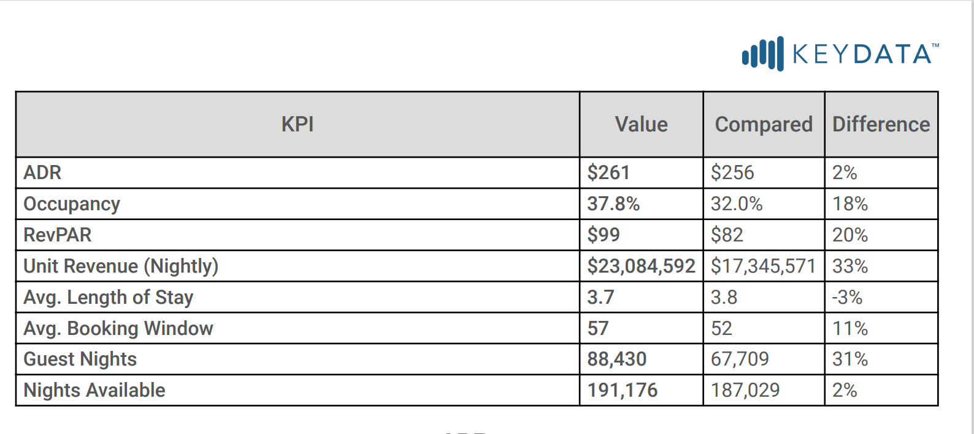

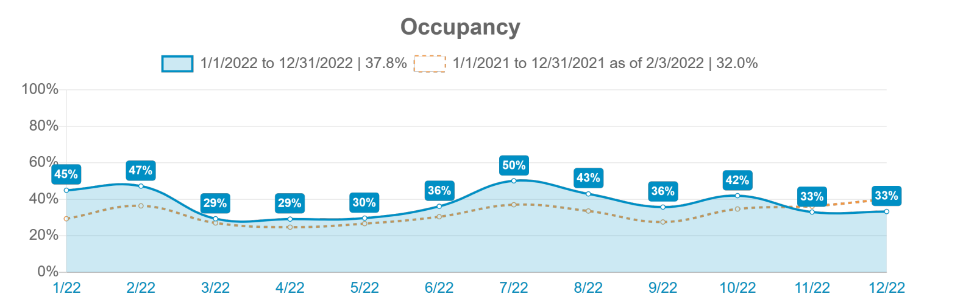

According to the West Virginia Tourism Office’s 2022 Annual Report:
Last year, West Virginia saw growth in all nine travel regions. Tourism’s economic impact is the highest in the state’s history with visitors spending approximately $13.6 million per day.
Source: West Virginia Travel Impacts, Dean Runyan Association, 2021
Tucker County:
- 81.1 million, Annual Travel Spending
- 1,030 Tourism Supported Jobs

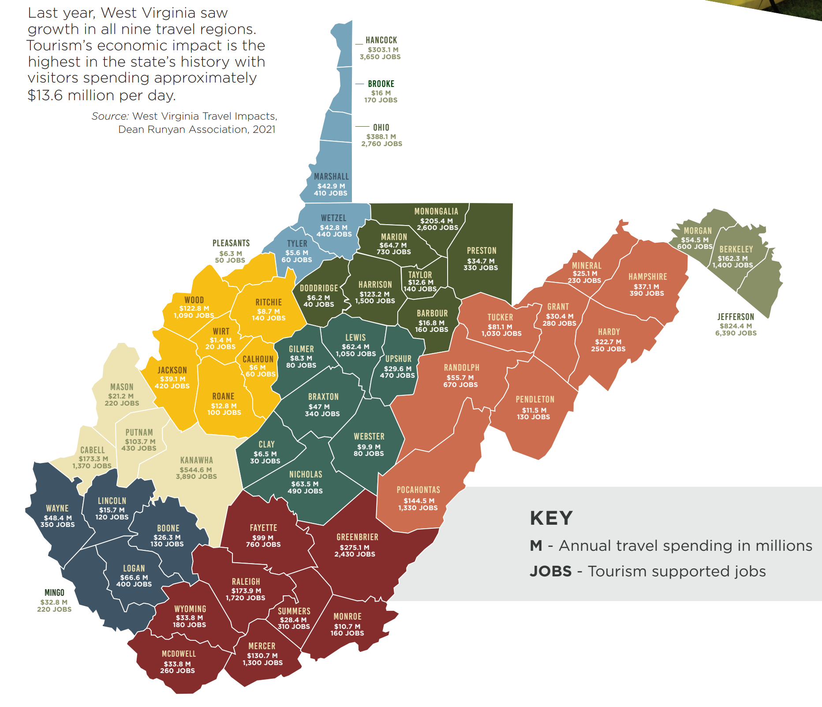

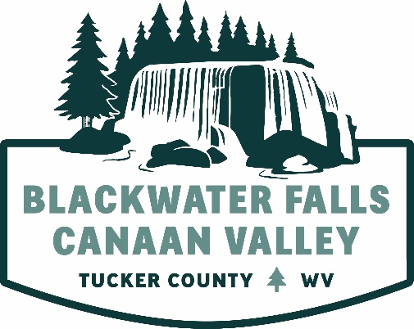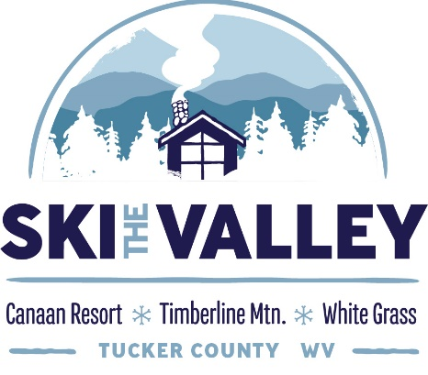

Tucker County Convention and Visitors Bureau
Po Box 565 / 410 William Ave.
Davis, WV 26260
800-782-2775 / 304-259-5315
canaanvalley.org / gettuckered.com / skithevalley.com

