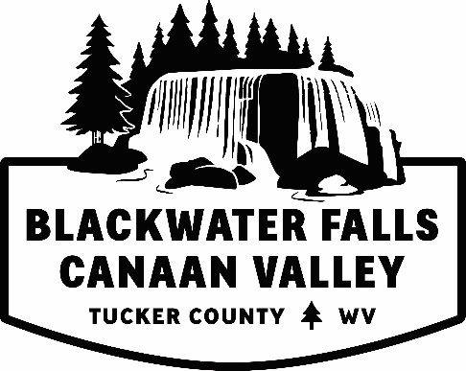
Marketing Sponsorship
The Tucker County Convention and Visitors Bureau (CVB) is offering the opportunity of financial assistance with marketing and advertising the county as a premier vacation, meeting and special event destination. The goal for this program is to enhance the tourism economy, increase overnight visitation, increase expenditures by visitors and assist in growing Tucker County a tourism destination.
We request that this form be filled out and returned to the Tucker County CVB office 30 days prior to the next CVB Board Meeting, held monthly. The proposed funding request must promote to visitors outside of a 50 mile radius. If this is for business assistance, explain how this will assist in growth to your business and in turn the tourism economy.
Please submit to Jessica Waldo, Executive Director, by mail or email.
Allowable advertising expenses include but not limited to:
- Print – magazine, newspaper
- Internet – display ad, e-newsletters, social media, etc.
- Broadcast – television, radio
- Printing Costs – brochures, postcards, rack card, flyer, maps
- Website
The CVB requests their logo, website and contact information be displayed when suitable.
A follow up presentation will be required within 90 days of using the monies that were given to your organization.
Tucker County Convention and Visitors Bureau
Po Box 565 Davis, WV 26260
304-259-5315
www.canaanvalley.org
Jessic@canaanvalley.org

Marketing Sponsorship Request Form
Applicant Organization:
Contact Person:
Address:
Phone:
Email:
Submission date:
Dates monies will be needed by:

Amount you are requesting:
What will these monies being used for?
If needed attach a separate detailed spread sheet. Please be as specific as possible. Breakout each placement and the cost associated and the dates, if suitable.

Have you or do you plan to ask for funds from another county organization for this project?
Yes (__) or No (__)
If Yes, please provide the following information:
Organization Awarding Funds / Usage / Amount Requested or Received

1.)

2.)

3.)

4.)

5.)

Have you previously requested sponsorship monies from the Tucker County CVB?
Yes (__) or No (__)

Yes, please provide when (date/year), amount and usage.

Please provide a short description of your business, organization, and/or event. The dates of the event, when the monies will be used, attendance to event (if applicable), etc. Please provide how these monies will assist in growing Tucker County as a tourism destination and/or assist with your business.

Summary Report
To be submitted within 90 days of using the sponsorship monies.
Applicant Organization:
Contact Person:
Amount Awarded:
Dates of Usage:

Please explain how the sponsorship monies were used. Provide any copies of materials, screenshots, commercials, etc.
Would you deem the event and usage of monies a success? Please explain.
Please provide any attendance numbers and/or how many room nights were generated.
Will you request sponsorship monies again in the future?

Thank you for participating in the Tucker County CVB Marketing Sponsorship Program.
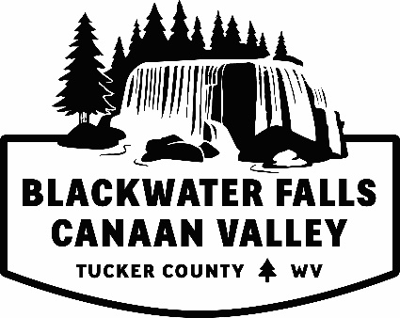
Tucker County Convention & Visitors Bureau
Po Box 565 Davis, WV 26260
304-259-5315
www.canaanvalley.org
jessica@canaanvalley.org

