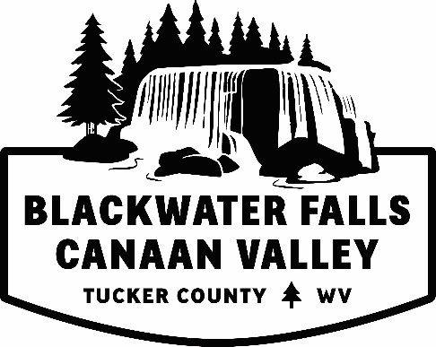
Tourism Sponsorship
The Tucker County Convention and Visitors Bureau (CVB) is offering the opportunity of financial assistance with a Tourism Development. The goal for this program is to enhance the county’s tourism product and providing the guest the best experience with visiting Tucker County.
We request that this form be filled out and returned to the Tucker County CVB office 30 days prior to the next CVB Board Meeting, held monthly. If this is for business or non-profit assistance, explain how this will assist in growth to your business or organization and in turn the tourism economy.
Please submit to Jessica Waldo, Executive Director, by mail or email.
Example of Tourism Sponsorships but not limited to:
- Trail maintenance or development
- Signage
- Maps
- Administrative
- Grant partnerships
The CVB requests their logo, website and contact information be displayed when suitable.
A follow up presentation will be required within 90 days of using the monies that were given to your organization.
Tucker County Convention and Visitors Bureau
Po Box 565 Davis, WV 26260
304-259-5315
www.canaanvalley.org
Jessic@canaanvalley.org

Tourism Sponsorship Request Form
Applicant Organization:
Contact Person:
Address:
Phone:
Email:
Submission date:
Dates monies will be needed by:

Amount you are requesting:
What will the funds request be used for? Will this be a one-time request or will continuous funding be needed?
If needed attach a separate detailed spread sheet. Please be as specific as possible. Include breakout pricing if applicable.

Have you or do you plan to ask for funds from another organization (county, grant, non-profit) for this specific project?
Yes (__) or No (__)
If Yes, please provide the following information:
Organization Awarding Funds / Usage / Amount Requested or Received

1.)

2.)

3.)

4.)

5.)

Have you previously requested monies from the Tucker County CVB?
Yes (__) or No (__)

Yes, please provide when (date/year), amount and usage.

Please provide a short description of your business, organization, and/or event. Also include a description on how this project and the funds requested will assistance in improving our Tourism Product. What is the planned end result of this project.

Summary Report
To be submitted within 90 days of using the sponsorship monies.
Applicant Organization:
Contact Person:
Amount Awarded:
Dates of Usage:

Please explain how the sponsorship monies were used. Provide any copies of materials, photos, and results.
Would you deem the usage monies a success? Please explain.
Have you received any feedback?
Will you request sponsorship monies again in the future?

Thank you for participating in the Tucker County CVB Tourism Sponsorship Program.
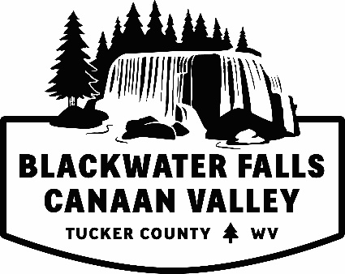
Tucker County Convention & Visitors Bureau
Po Box 565 Davis, WV 26260
304-259-5315
www.canaanvalley.org
jessica@canaanvalley.org

