2023 Annual Report
Tucker County, WV Convention and Visitor’s Bureau
Prepared By:
Jessica Waldo
Executive Director

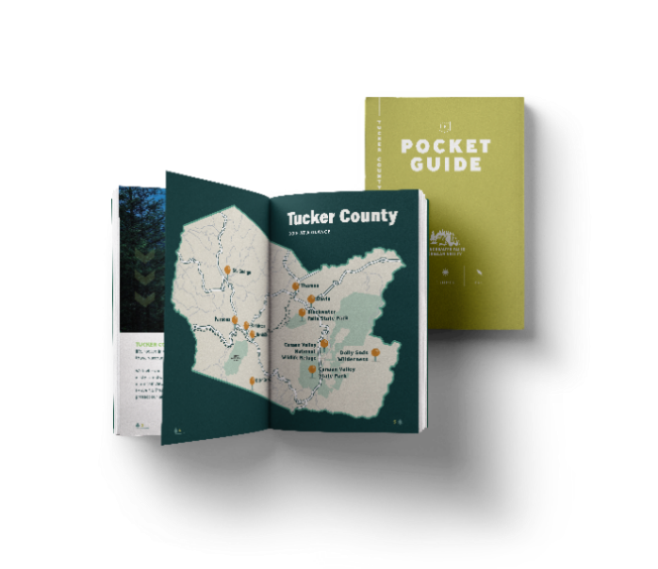

Mission Statement:

“The Tucker County Convention & Visitor’s Bureau, a private, non-profit sales and marketing corporation will, through aggressive sales, marketing and informational campaigns, strive to establish the Canaan Valley/Blackwater Falls/Tucker County area as a premier vacation, meeting, and special event destination thereby enhancing the tourism economy in Tucker County”

The Tucker County Convention & Visitors Bureau’s (CVB) mission is to support, sustain and assist in the growth of the Tourism Industry in the county. To fulfill that mission, the CVB expends the majority of its budget on advertising. In 2023 the CVB budget reflected 74% on advertising, 22% on payroll, and 4% on operational. Exceeding the WVACVB accreditation guidelines and the CVB Oversight Bill budget requirements of 40% on advertising, 40% on payroll, and 20% on operational.

2023 Board of Directors:

- Tom Price President, Canaan Valley Representative.
(Term expires 12/31/23)
- Matt Baker, Vice President, Canaan Valley Representative.
(Term expires 12/31/24)
- Glenda Crawford, Director, Canaan Valley Representative.
(Term expires 12/31/25)
- Jessica Wamsley, Director, Parsons Area Representative.
(Term expires 12/31/25)
- Brent Markwood, Treasurer Davis/Thomas Representative.
(Term expires 12/31/23)
- Kevin White, member at large, Tucker County OEMS Director.
(Term expires 12/21/23)
- Joy Malinowski, a member at large, owner of Cooper House and the Billy.
(Term expires 12/21/24)
- Fred Davis, Tucker County Commission

The Staff:

- Jessica Waldo,
Executive Director
- Brian Sarfino,
Marketing Manager
- Barbara Worden, Office Administrator / Information Specialist

Director’s Notes:
It’s been a wide ride for tourism in Tucker Couty. We are now starting to ride out the Covid Tidal Wave. This is the first year since Covid, that we are seeing our tourism numbers level out. In 2023, we received a total of $678,638 in hotel/motel tax throughout the county. In 2022, we received $677,797 and in 2021 we received $633,187 in h/m tax. We started to see the increase traffic from Covid in summer of 2020 and winter of 2021 when we started to see the effects of the investment into the new Timberline.
Despite having marginal winter weather, our winter season continues to be a larger contributor. We anticipate to see this continue in the future, as a phase 1 investment is made into snowmaking at Canaan Resort. Along with new amenities, like the snow bike in 2023/2024 winter season. According to KeyData our highest occupancy was during February 2023 and closely followed by July 2023.
Spring still continues to be our only true shoulder season. It’s a slower time between winter and summer season. We do see visitors for the Canaan Valley Half Marathon, along with fishermen and boaters looking to enjoy the river.
Summer kicks of mid-May and early June and tourism traffic increases every day during this time. We typically see a short break in visitors at the end of August and beginning of September when school starts. But fall travelers continue through mid-Oct and can be some of the busiest times for us. This is when typically, we are start seeing the empty nesters visiting the area.
In March of 2023, the CVB applied for funding for a new Visitor Center from the Congressionally Directed Spending under USDA Rural Development. Our request of 1.28 million with a cash match of $350,000 was approved. We have slowly moved forward with this project, as we are waiting for a federal budget to be approved. Finally approved on Friday, March 8th!
We continued with the Take in Tucker campaign for 2023. Our marketing plan included $125,000 in a Spring/Summer campaign, $25,000 in Fall and $130,000 in Winter. We also spent $20,000 in video development for the “Greater Parsons Area” of a 3-year series. These videos were intended to give the perspective of frequent travels to the area and let them tell why they love Tucker County. These videos ran in later summer in 2023 and will run again in Spring 2024.

We 2023 we had 10 applicants for Marketing Sponsorships and we awarded $13,275. We continue to see an increase in requests and currently revamping the program to benefit everyone. Starting in 2023 we created Tourism Sponsorships; our first partnership was with Heart of Highlands and again in 2024.
In 2023, we printed 15,000 Visitors Guides. For this guide we changed the cover to reflect one of our iconic overlooks in the fall. We supported this piece with printing new spring/summer pockets and a winter pocket guide. We continued our Scavenger Hunt in the county and printed a new passport for this.
September of 2023 brought the WV Governor’s Conference on Tourism. The CVB hosted a welcome reception at the Purple Fiddle and catered by Picnic in Thomas. Canaan Valley Resort sold out their lodge and local lodging options for the conference. The WV Tourism Office reported the was the best attended conference to date! I was honored to partner with Canaan Valley Resort to host my colleagues in our wonderful county.
Thank you,

Jessica Waldo
Executive Director
jessica@canaanvalley.org

2023 Marketing “Take in Tucker”
Summer: $125,000
- Messaging Focus: General Take in Tucker and Challenge (Passport)
- Tentative Tactics: Display and video ads
- Themes: General - take in the arts, music, and outdoors
- Target audience: Interest targeting according to themes
- Geography: WV and surrounding areas, including North Carolina, Virginia, Maryland, Ohio, Pennsylvania, New York, Tennessee, Michigan, Illinois, and the DC Metro area
- Goals: Landing page clicks and guide requests
- Flight dates: May 1, 2023 - August 15, 2023
Fall: $25,000
- Messaging Focus: Take in Tucker
- Tentative Tactics: Display ads
- Themes: Fall scavenger hunt or photo contest to promote Tucker County as a fall
- destination
- Target audience: Interest targeting according to themes
- Geography: WV and surrounding areas, including North Carolina, Virginia, Maryland, Ohio, Pennsylvania, New York, Tennessee, Michigan, Illinois, and the DC Metro area
- Goals: Landing page clicks and guide requests
- Flight dates: August 16, 2023 - October 20, 2023
Ski The Valley 2023/2024: $130,000
- Messaging Focus: Ski the Valley
- Tentative Tactics: Display and video ads
- Themes: Winter sports and small-town charm
- Target audience: Interest targeting according to themes
- Geography: WV and surrounding areas, including North Carolina, Virginia, Maryland, Ohio, Pennsylvania, New York, Tennessee, Michigan, Illinois, and the DC Metro area
- Goals: Landing page clicks
- Flight dates: November 1, 2023 - March 1, 2024

Printed Materials:
- Take in Tucker Spring/Summer/Fall Pocket Guide (Refresh)
- Take in Tucker Passport (Refresh)
- Ski the Valley Winter Pocket Guide (Refresh)
- Tucker County Dining Guide (New)
WV Tourism Co-op: $114,115
In 2023 we continued to participate in the WV Tourism Co-Op program. This program is a 50/50 split with the WV Tourism Office. The CVB purchased $114,115 in advertisement; 2022/2023 winter/fall program $77,800 and Spring/Summer $36,315 summer program.
During the 2023 Winter season we spent a larger amount to participate in a Branding Campaign. We purchase Car-vertise in Charlotte, Nc and Cincinnati, Oh. Cars were located in strategic places and wrapped with WV Tourism and Ski the Valley messaging and logos. Participants were given and incentive to register to win a trip to Tucker County. Emails and Addresses were captured.

Video/Photo Shoot: $20,000
To add to Tucker County’s asset library, we will schedule one photo/video shoot for the 2023 fiscal year in Parsons.
- Dining
- Splash Park
- Kayaking, canoeing, floating, paddle boarding, fishing
- Cork’s Turkey Knob Wines
- Cork’s Ford Battlefield
- Murals and Downtown
- Otter Creek
- Allegheny Rail Trail
- Pickin’ in Parsons
- Deliverables: Photos and 2 interview-style videos

Campaign Summary:

Conversion Data:
- Visitor Guide Requests: 45
- Newsletter Guide Requests: 286
- Internal Partner Clicks: 4,322
- External Partner Clicks: 153
- Contact Form Submissions: 1,390
Campaign Data:
Ski the Valley
● Impressions
○ 2021: 3,396,021
○ 2022: 7,018,672
○ 2023: 7,543,622
● Clicks
○ 2021: 41,765
○ 2022: 68,189
○ 2023: 91,377
● CTR
○ 2021: 1.23%
○ 2022: 0.97%
○ 2023: 1.21%
The increase in costs across the 2021, 2022 and 2023 Ski the Valley campaigns aligns with a simultaneous rise in impressions and clicks. Impressions showed steady growth from 2022 to 2023, accompanied by year-over-year increases in clicks.
Spring/Summer
● Impressions
○ 2021: 4,623,191
○ 2022: 24,684,227
○ 2023: 44,091,887
● Clicks
○ 2021: 29,258
○ 2022: 63,018
○ 2023: 105,332
● CTR
○ 2021: 0.63%
○ 2022: 0.22%
○ 2023: 0.24%
From 2021 to 2023, there has been a significant surge in impressions from the spring/summer campaigns, indicating a substantial increase in visibility. Moreover, the number of clicks almost doubled from 2022 to 2023, reflecting a notable rise in user engagement. This surge in clicks and impressions was accompanied by a corresponding increase in the price, suggesting a correlation between the three metrics.
Fall
● Impressions
○ 2021: 8,834,486
○ 2022: 6,063,129
○ 2023: 5,734,832
● Clicks
○ 2021: 8,221
○ 2022: 11,892
○ 2023: 8,136
● CTR
○ 2021: 0.09%
○ 2022: 0.2%
○ 2023: 0.14%

Impressions declined over the three-year period, with a notable drop in 2022, while clicks increased in 2022 but decreased in 2023. This led to fluctuations in the click-through rate (CTR) with an improvement in 2022 and a decline in 2023. Costs of the campaigns also varied, with costs decreasing in 2022 and rising again in 2023.
2020 Paid Campaign Performance: The top-performing campaign for 2020 was “Get Back to Adventure” with 34,187 clicks and 931,835 impressions with an average CTR of 3.67%. “Winter 2020” also yielded impressive results with a low overall spend and close to 20,000 clicks from TTD and FB platforms
In 2019 we saw 118,765 web site visits. 58,538 clicks were organic visits. Our average page use was 2.44 pages and the average session duration was 1.41 minutes. Females between the ages of 35-44 years old remained as the top users. User age was nearly equal from the ages of 25-64. The top10 states were as follows; WV, VA, DC, PA, MD, OH, NC, NY, TN, and FL. 62.97% bounce rate.
Website Stats 2023:
83.66% of website visitors were using their tablet or mobile device.
The biggest age range of visitors are: 55-64 (2.96%), 45-54 (2.58%), 35-44 (2.45%), 65+ (2.35%). *Percentages are low due to 87% of users’ ages being unknown
Top 10 pages of 2023:
- Ski the Valley - Canaan Valley, WV
- #TakeInTucker - Canaan Valley, WV
- Outdoor Recreation - Canaan Valley, WV
- Get Tucker'd in Tucker County, West Virginia - Canaan Valley, WV
- Take In Tucker Scavenger Hunt 2023 - Canaan Valley, WV
- Things to Do - Canaan Valley, WV
- Get Tucker'd in Tucker County, West Virginia - Canaan Valley, WV
- Where to Stay - Canaan Valley, WV
- Get Your Guide - Canaan Valley, WV
- Dining & Breweries in Tucker County - Canaan Valley, WV
Most site traffic comes from Virginia (12.51%), followed by:

- Pennsylvania (11.28%)
- Ohio (9.62%)
- New York (9.46%)
- West Virginia (9.43%)
- North Carolina (7.79%)
- Maryland (5.65%)
- Michigan (5.04%)
Site traffic from cities:

- New York (5.47%)
- Ashburn (4.39%)
- Washington (2.47%)
- Pittsburgh (2.45%)
- Columbus (2.29%)
- Chicago (1.98%)
- Baltimore (1.20%)
Based on interest categories of site visitors, target audiences enjoy:
- News
- Travel
- Family
- Hiking
- Shopping
- Food and Beverage
- Pets
Top 15 affinity categories shared by the most visitors to the site:
- News & Politics/Avid News Readers
- Media & Entertainment/Movie Lovers
- Media & Entertainment/TV Lovers
- Media & Entertainment/Light TV Viewers
- Lifestyles & Hobbies/Shutterbugs
- Shoppers/Shopping Enthusiasts
- Travel/Travel Buffs
- Home & Garden/Home Decor Enthusiasts
- Food & Dining/Cooking Enthusiasts
- Lifestyles & Hobbies/Pet Lovers
- Lifestyles & Hobbies/Outdoor Enthusiasts
- Technology/Social Media Enthusiasts
- Sports & Fitness/Sports Fans
- News & Politics/Avid News Readers
- Media & Entertainment/Music Lovers
Top Organic Search Terms by Impressions:
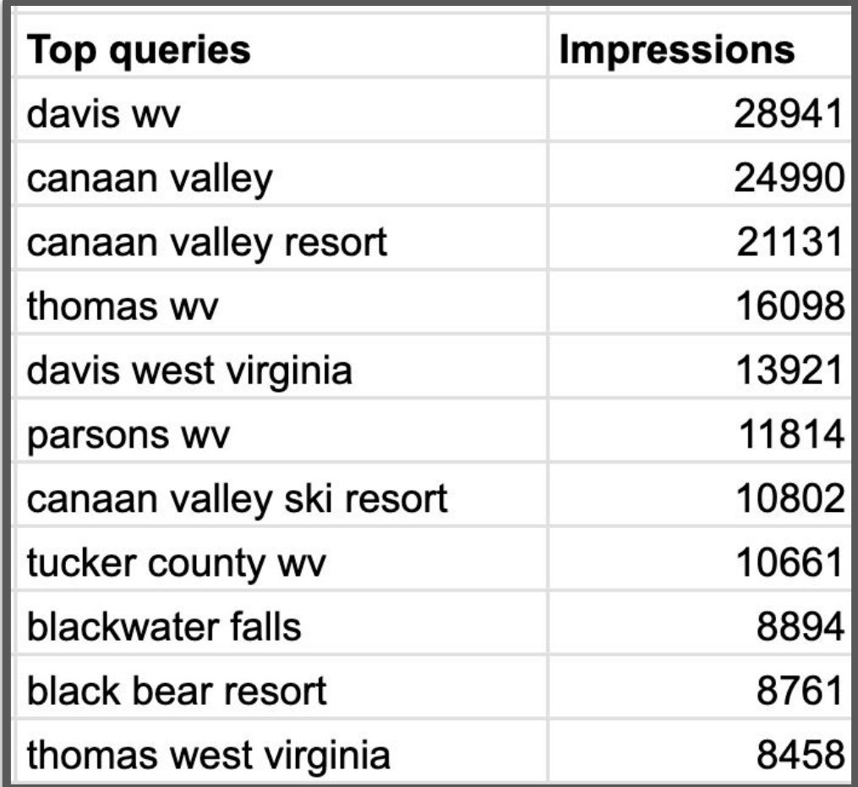
Top Organic Search Terms by Clicks:
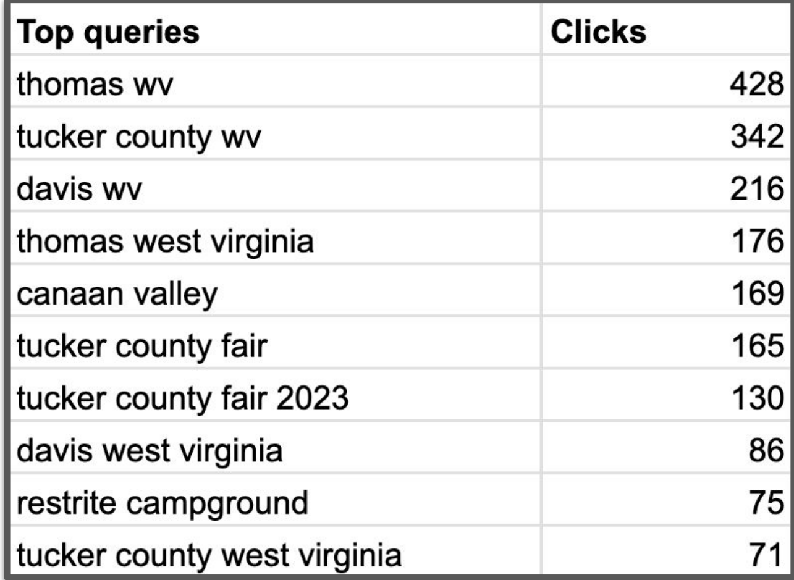
Top Organic Pages by Clicks:
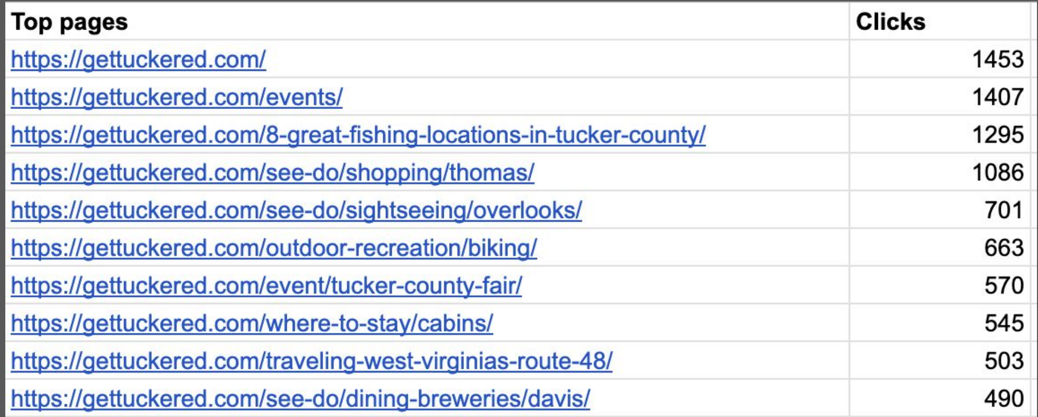
Top Organic Pages by Impressions:
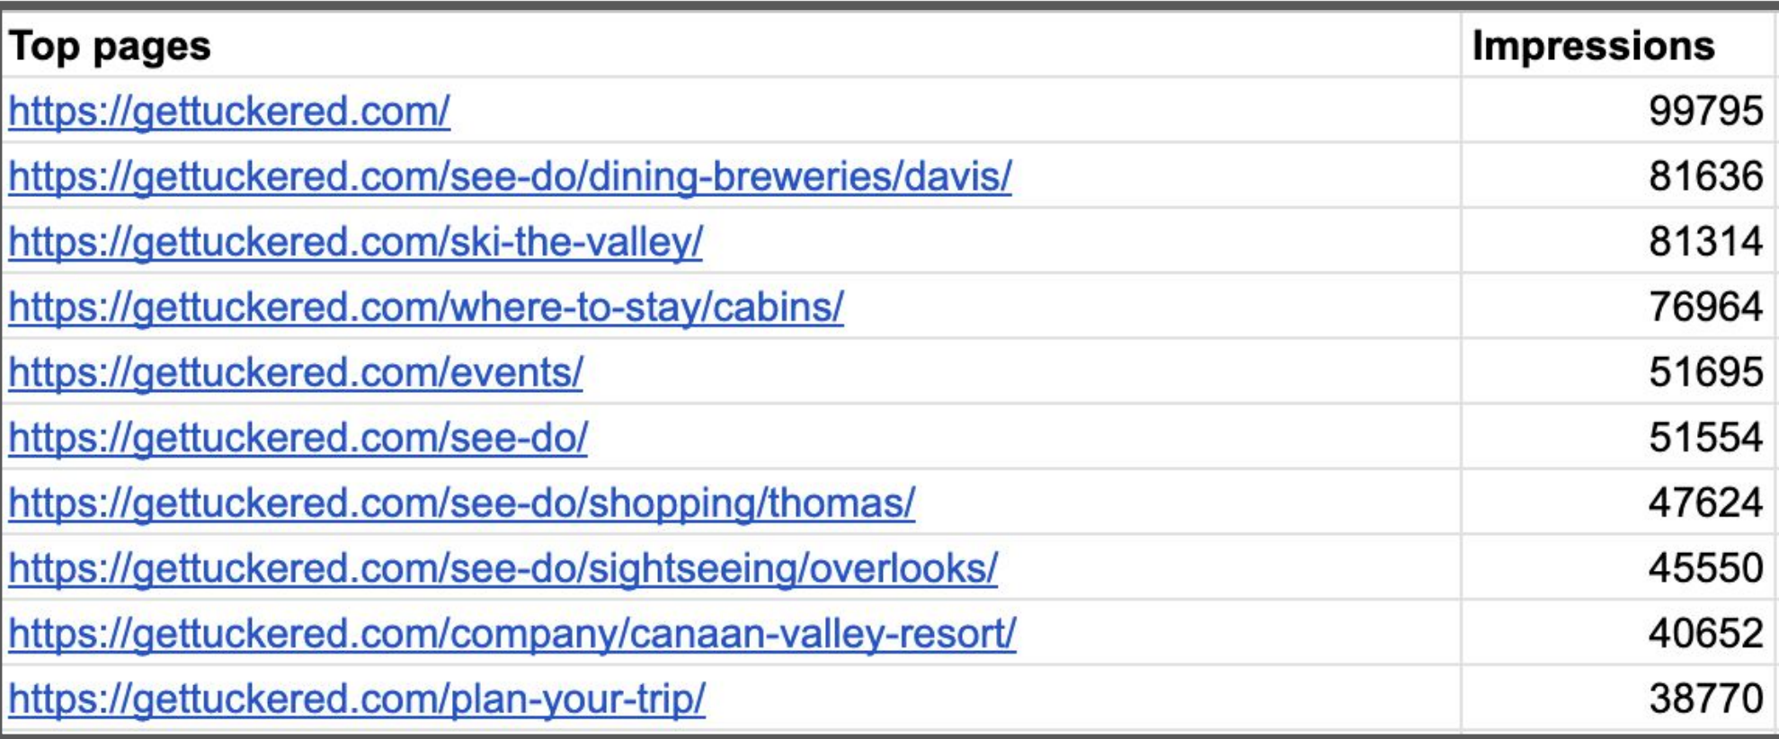
Email Campaigns:
On our mailing list we have roughly 14,000 recipients that have signed up to receive our Newsletters. Of those 14,000 we around 10,000 that subscribe. These numbers fluctuate throughout the year. We typically have a 22% open rate. Providing a loyal following. If you like to subscribe, please sign up on the website.

Website Blogs:
There were are total of 10 blogs in 2023. These blogs are intended as trip inspirations and helpful travel hints while visiting the area.

Social Media:
Facebook:
- Tucker County, WV over 26,000 followers
Utilizing this platform, we can reach over 630,000 and see engagement over 20,000 from our followers.
Instagram:
- Tucker County, WV over 16,000 followers
This account can reach over 7,000 and has close to 400 engagement.
- Ski the Valley over 3,000 followers
YouTube:
Continues to grow, but not as fast as we hoped. We continue to utilize this platform for our full length Take in Tucker videos.
Marketing Sponsorships:
In 2023 we awarded $13,275 in Marketing Sponsorships to 10 organizations.
- Cranberry Joe; CV Half Marathon, Moonlight Under the Falls, CV Trail Run
- Sunrise Scramble
- Parsons VFD triathlon
- Highlands Trail Foundation; Blackwater Canyon Run
- Tucker County Fair
- Five River Campground
- ArtSpring
- Creature; Thomas Artwalks
- Mountain State Brewing
- Alpine Festival; Celebration of the Arts and Leaf Peepers
Community Partners: Below is a list of organizations we have partnered with and/or the CVB is an active member.
- Cheat River Water Trail
- Blackwater Biking Association
- Chamber of Commerce
- Run For It
- Blackwater Falls Foundation
- Heart of the Highlands
- Alpine Festival Association
- Mon Forest Towns; Marketing Committee
- Highlands Trail Foundation
- Potomac Highlands Creative Economy

Association & Organizations: State and Regional organizations we are members and participate with in various ways.
- WV Association of Convention & Visitors Bureaus
- WV Hospitality & Travel Association
- Hospitality University
- WV Governor’s Conference on Tourism
- WV Ski Areas Association
- Tourism Day at the Capital
- Southeast Tourism Society
- WVU Sustainable Rural Tourism Video Series
- Potomac Highlands Creative Economy
- Mountaineer Trail Network
Tucker County Information Center:
The Convention and Visitors Bureau operates the Tucker County Information Center located in downtown Davis on the corner of 4th Street and William Ave. The center is open 7 days a week from 9am to 5pm and provides service and information for guests to the area. The Information Center is stocked with the following literature:
- County, Regional and State wide Information
- Local Lodging Information
- Local Attraction Information
- Dining Information and most menus
- Hiking and Biking maps for all areas
- County and WV Road Maps
- Area Event Flyers
- Activity Itineraries
- Pocket Guides for Tucker County
- WV DNR hunting and fishing regulations
- Fax, Copy and Printing Services
- UPS Drop Off
Funding:
The main source of funding for the Tucker County Convention and Visitors Bureau is 50% of the hotel/motel occupancy tax collected throughout Tucker County. This 6% fee is collected from visitors staying 30 days or less in local lodging facilities. The Tucker County Commission disburses 50% of the 6% collected to the CVB and remaining 50% to the Tucker County Parks & Recreation Board, Camp Kidd, County Fire & EMS services and any other historical or beautification projects.
County H/M Tax (50%):
Year | Amount | Year | Amount
2015 | $345,636 | 2020 | $322,149
2016 | $346,191 | 2021 | $589,004
2017 | $342,896 | 2022 | $544,485
2018 | $374,843 | 2023 | $531,910
2019 | $338,146
*2019 December payment was missing collection for a local lodging facility

Davis and Thomas H/M Tax (50%):
Year | Davis | Thomas | Year | Parsons
2015 | $13,113 | $5,380 | 2022 | $1,606
2016 | $12,586 | $2,913 | 2023 | $4,137
2017 | $15,684 | $3,188
2018 | $18,438 | $3,252
2019 | $23,541 | $2,256
2020 | $25,145 | $7,093
2021 | $37,529 | $6,654
2022 | $118,260 | $13,446
2023 | $125,616 | $16,975
*In 2015 Davis increased their H/M tax from 3% to 6%

KeyData 2023 Snapshot: Vrbo.com and Airbnb.com
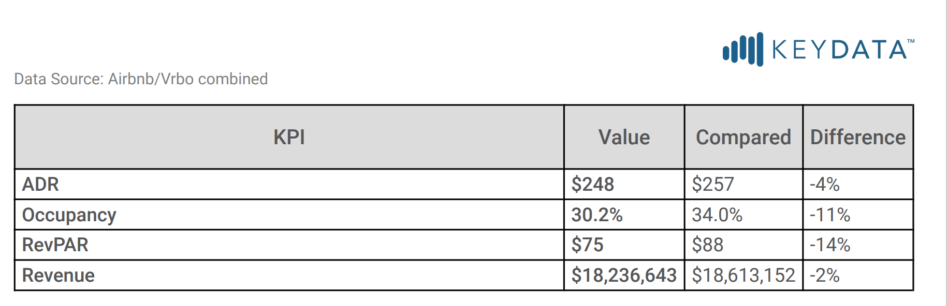

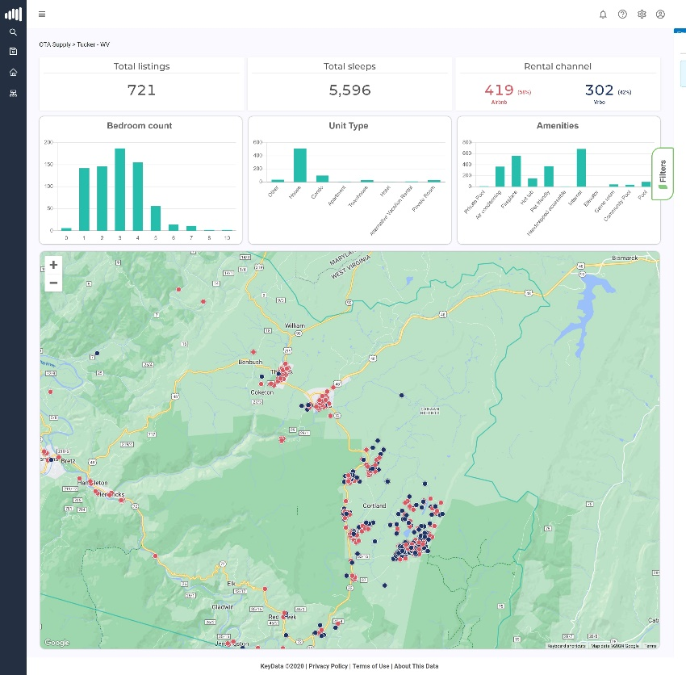

2023 Cover
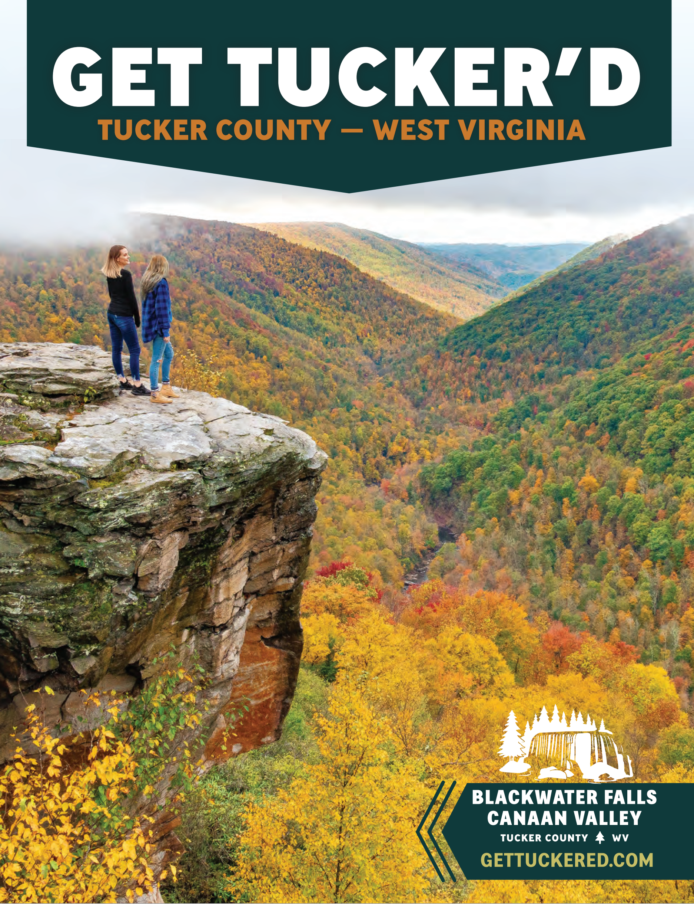

WV Co-Op Ads:
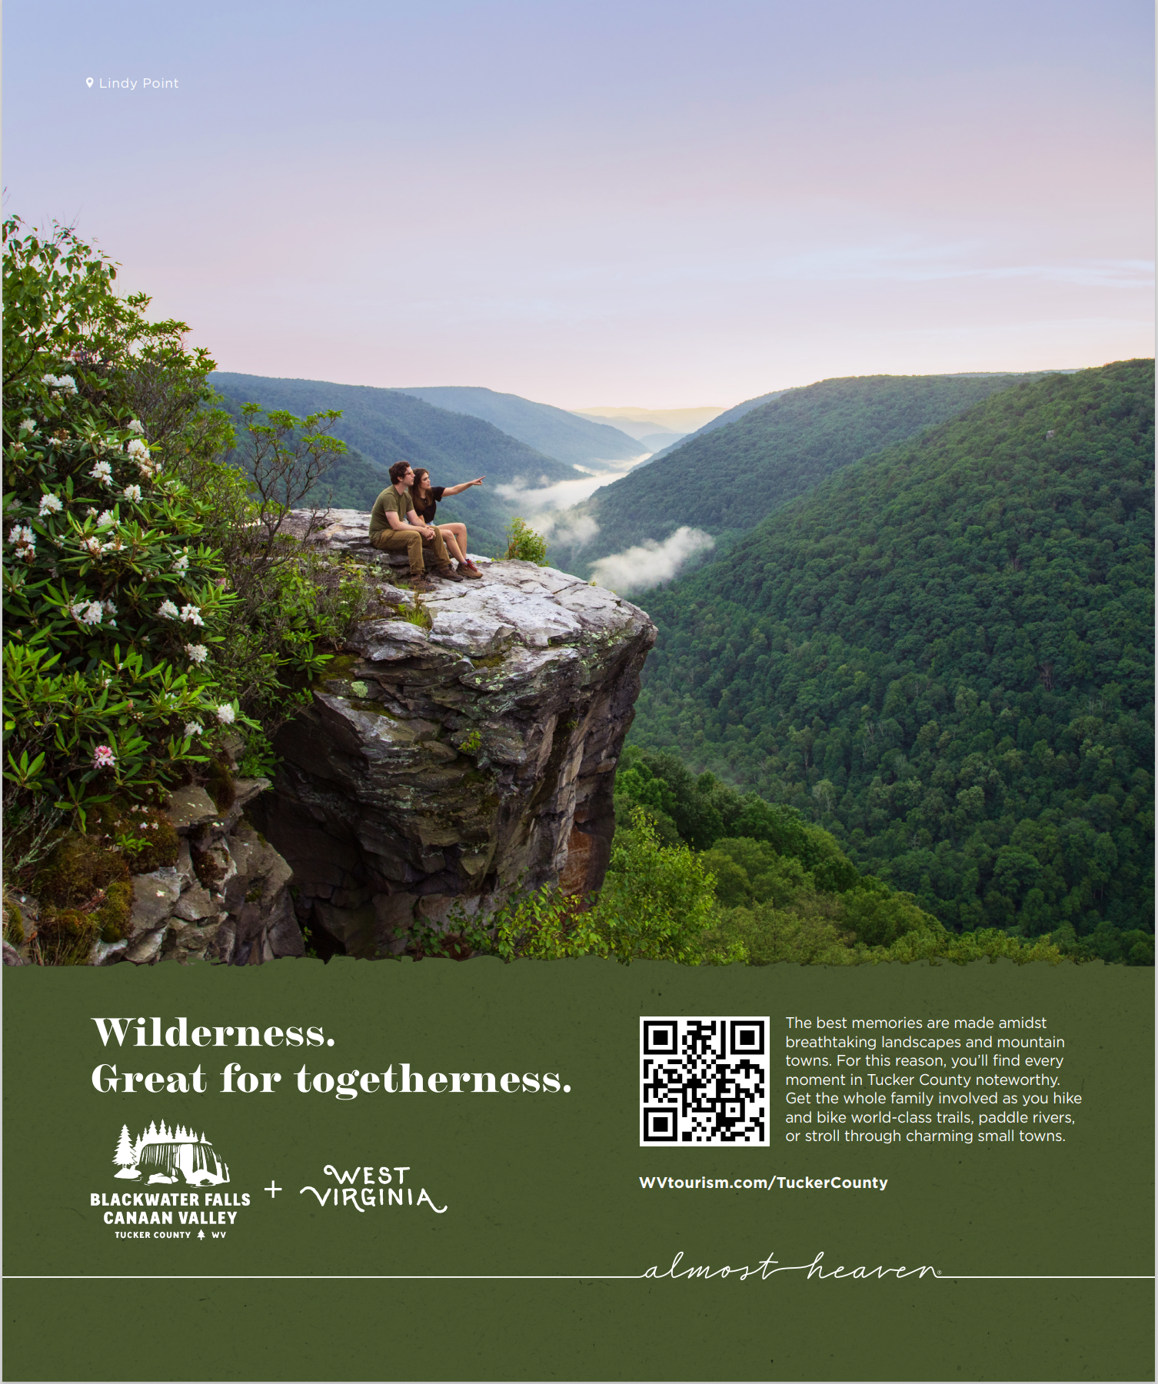

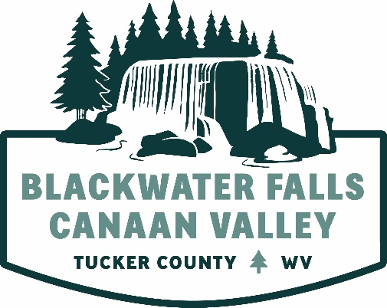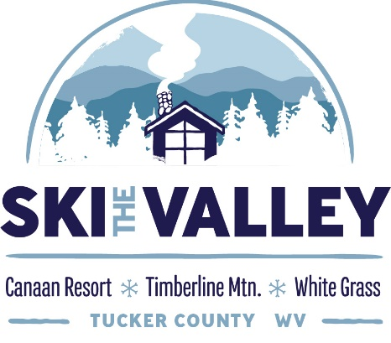

Tucker County Convention and Visitors Bureau
Po Box 565 / 410 William Ave.
Davis, WV 26260
800-782-2775 / 304-259-5315
canaanvalley.org / gettuckered.com / skithevalley.com

